SEC Form 4
FORM 4 |  | UNITED STATES SECURITIES AND EXCHANGE COMMISSION  Washington, D.C. 20549  STATEMENT OF CHANGES IN BENEFICIAL OWNERSHIP  Filed pursuant to Section 16(a) of the Securities Exchange Act of 1934  or Section 30(h) of the Investment Company Act of 1940
  OMB APPROVAL
  OMB Number: | 3235-0287
  Estimated average burden
  hours per response: | 0.5
 | Check this box if no longer subject to Section 16. Form 4 or Form 5 obligations may continue. See Instruction 1(b).
 | Check this box to indicate that a transaction was made pursuant to a contract, instruction or written plan for the purchase or sale of equity securities of the issuer that is intended to satisfy the affirmative defense conditions of Rule 10b5-1(c). See Instruction 10.
1. Name and Address of Reporting Person*  (Street) | 2. Issuer Name and Ticker or Trading Symbol  DAKTRONICS INC /SD/ [ DAKT ]  Foreign Trading Symbol | 5. Relationship of Reporting Person(s) to Issuer  (Check all applicable)
  Bowser Mark F
  (Last) | (First) | (Middle)
  201 DAKTRONICS DRIVE
  BROOKINGS | SD | 57006
  (City) | (State) | (Zip)
   | Director |  | 10% Owner
   | Officer (give title below) |  | Other (specify below)
3. Date of Earliest Transaction (Month/Day/Year)
09/17/2026
 | 4. If Amendment, Date of Original Filed (Month/Day/Year) | 6. Individual or Joint/Group Filing (Check Applicable Line)
  Form filed by One Reporting Person
  Form filed by More than One Reporting Person
Table I - Non-Derivative Securities Acquired, Disposed of, or Beneficially Owned
1. Title of Security (Instr. 3) | 2. Transaction Date (Month/Day/Year) | 2A. Deemed Execution Date, if any (Month/Day/Year) | 3. Transaction Code (Instr. 8) |  | 4. Securities Acquired (A) or Disposed Of (D) (Instr. 3, 4 and 5) |  |  | 5. Amount of Securities Beneficially Owned Following Reported Transaction(s) (Instr. 3 and 4) | 6. Ownership Form: Direct (D) or Indirect (I) (Instr. 4) | 7. Nature of Indirect Beneficial Ownership (Instr. 4)
1. Title of Security (Instr. 3) | 2. Transaction Date (Month/Day/Year) | 2A. Deemed Execution Date, if any (Month/Day/Year) | Code | V | Amount | (A) or (D) | Price |  | 6. Ownership Form: Direct (D) or Indirect (I) (Instr. 4) | 7. Nature of Indirect Beneficial Ownership (Instr. 4)
Common Stock | 09/17/2026 |  | A(1) |  | 6,594(1) | A | $0 | 10,129 | D
Table II - Derivative Securities Acquired, Disposed of, or Beneficially Owned
(e.g., puts, calls, warrants, options, convertible securities)
1. Title of Derivative Security (Instr. 3) | 2. Conversion or Exercise Price of Derivative Security | 3. Transaction Date (Month/Day/Year) | 3A. Deemed Execution Date, if any (Month/Day/Year) | 4. Transaction Code (Instr. 8) |  | 5. Number of Derivative Securities Acquired (A) or Disposed of (D) (Instr. 3, 4 and 5) |  | 6. Date Exercisable and Expiration Date (Month/Day/Year) |  | 7. Title and Amount of Securities Underlying Derivative Security (Instr. 3 and 4) |  | 8. Price of Derivative Security (Instr. 5) | 9. Number of derivative Securities Beneficially Owned Following Reported Transaction(s) (Instr. 4) | 10. Ownership Form: Direct (D) or Indirect (I) (Instr. 4) | 11. Nature of Indirect Beneficial Ownership (Instr. 4)
 |  |  |  | Code | V | (A) | (D) | Date Exercisable | Expiration Date | Title | Amount or Number of Shares
Explanation of Responses:
1. Represents annual equity compensation in the form of a grant of restricted stock made under the Daktronics, Inc. 2025 Stock Incentive Plan. The award vests on August 23, 2027 and is subject to certain forfeiture provisions.
Remarks:
 | /s/ Mark F. Bowser, by Leah Kassalen, attorney-in-fact, pursuant to a POA filed herewith | 09/21/2026
 | ** Signature of Reporting Person | Date
Reminder: Report on a separate line for each class of securities beneficially owned directly or indirectly.
* If the form is filed by more than one reporting person, see Instruction 4 (b)(v).
** Intentional misstatements or omissions of facts constitute Federal Criminal Violations See 18 U.S.C. 1001 and 15 U.S.C. 78ff(a).
Note: File three copies of this Form, one of which must be manually signed. If space is insufficient, see Instruction 6 for procedure.
Persons who respond to the collection of information contained in this form are not required to respond unless the form displays a currently valid OMB Number.
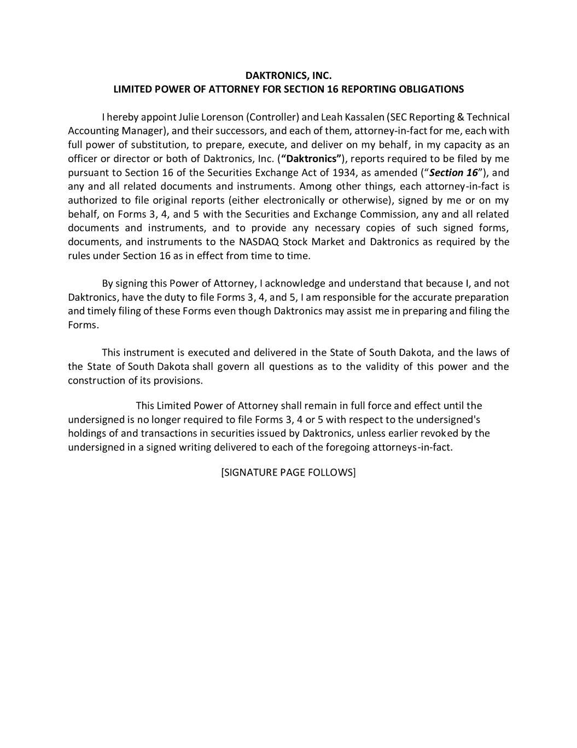

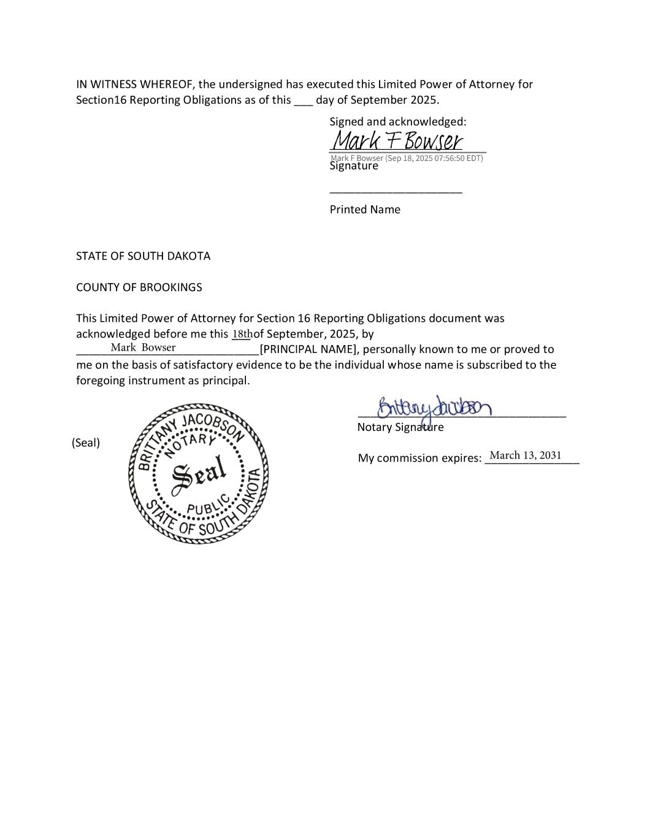
18th Mark Bowser March 13, 2031

